**Lab 12 Tasks**

**K20-1052 (S.M.HASSAN ALI)**

**Q1.**

#include<iostream>

#include<string>

#include<string.h>

#include<fstream>

using namespace std;

int main(){

string a;

cout<<"Enter the string: ";

getline(cin,a);

int len= a.length();

cout<<"The length of string is: "<<len<<endl;

fstream file;

file.open("q1.txt",ios::out);

if(!file){

cout<<"File not created\n\n "<<endl;

}

else{

cout<<"file has been created\n\n";

}

file<<a;

file.close();

file.open("q1.txt",ios::in);

string aa;

while(1){

getline(file,aa);

if(file.eof()){

break;

}

}

cout<<"The retrieved data from file is: ";

cout<<aa;

file.close();

}

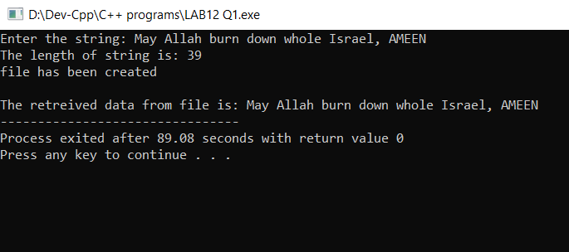

**Q2.**

#include <iostream>

#include <fstream>

#include<string>

using namespace std;

int main()

{

string line;

fstream file("original.txt", ios::in);

fstream temp("copy.txt", ios::out);

if(file && temp){

while(getline(file, line)){

temp << line << "\n";

}

cout << "String copied!! \n\n";

}

else

{

cout<<"String not copied!! \n\n";

}

file.close();

temp.close();

return 0;

}

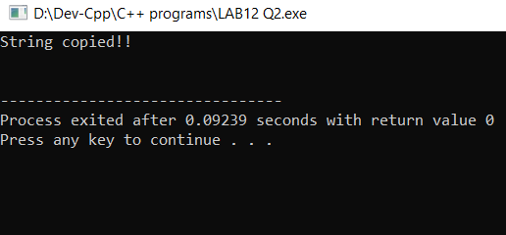

**Q3.**

#include <iostream>

#include <fstream>

#include <string>

using namespace std;

class person {

private:

string name;

int age;

public:

setdata(string n, int a){

name=n;

age=a;

}

getdata(){

cout<< "\n Name = " << name;

cout<< "\n Age = " << age;

}

};

int main() {

person person1;

fstream file;

file.open("person.bin", ios::out);

person1.setdata("SYED HASSAN",20);

file.write( ( char*) &person1, sizeof(person1));

file.close();

cout<< "\n Data Saved";

cout<< "\n\n Reading data from file: ";

file.open("person.bin", ios::in);

file.read((char*) &person1, sizeof(person1));

person1.getdata();

cout<<"\n\n";

file.close();

return 0;

}

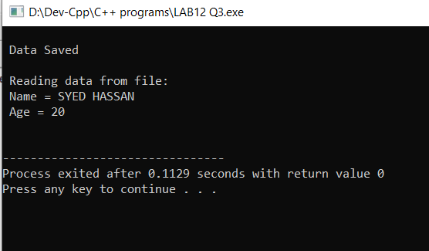

**Q4.**

#include <iostream>

#include <fstream>

#include<string>

using namespace std;

class Participants{

public:

int id[2],j;

string name[2];

int score[2];

int arr;

input(){

for(int i=0;i<2;i++){

cout<<"\n\nEnter id "<<i+1<<" :";

cin>>id[i];

getchar();

cout<<"Enter the name: ";

getline(cin,name[i]);

cout<<"enter the score: ";

cin>>score[i];

}

cout<<endl;

}

max() {

for(int i=0;i<2;i++) {

if(score[i] > score[i+1]) {

arr=score[i];

}

}

}

output(){

cout<<"READING FROM THE FILE: "<<endl<<endl;

for(int i=0;i<2;i++){

cout<<"Name:" << name[i] << endl;

cout<<"Score: " << score[i] <<endl;

cout<<"ID: " << id[i] <<endl<<endl;

}

cout<<"The maximum score is "<<arr<<endl;

}

};

int main(){

fstream file;

file.open("participant.dat",ios::out);

Participants p1;

p1.input();

p1.max();

file.write((char*)&p1, sizeof(p1));

file.close();

file.open("participant.dat", ios::in);

file.read((char*) &p1, sizeof(p1));

p1.output();

file.close();

}

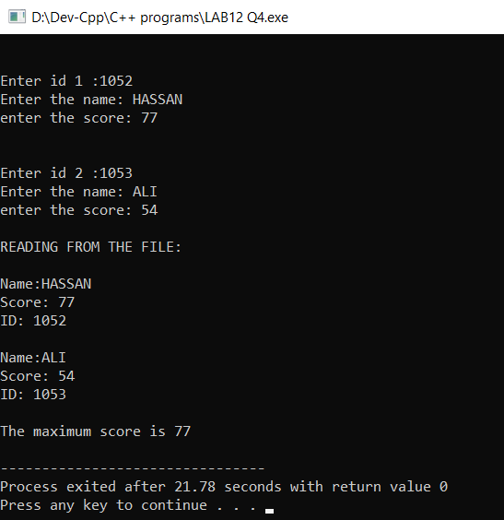

**Q5.**

#include <iostream>

#include <fstream>

#include<string>

using namespace std;

class Count{

public:

void countlines(){

fstream file;

file.open("STORY.txt",ios::in);

char str[80];

int count=0;

while(!file.eof())

{

file.getline(str,80);

if(str[0]!='A')

count++;

cout<<endl<<str<<endl;

}

cout<<"Number of lines not starting with A are "<<count;

file.close();

}

/* 1. If the file "STORY.TXT" contains the following lines,

2. The rose is red.

3. A girl is playing there.

4. There is a playground.

5. An aeroplane is in the sky.

6. Numbers are not allowed in the password.

7. The function should display the output as 3.

5 lines starting with not "A"

*/

};

int main(){

Count c;

c.countlines();

}

